Parameter Efficient Models for Malaria Detection and Classification Using Small-Scale Imbalanced Blood Smear Images


Akhiyar Waladi*¹, Hasanatul Iftitah², Yogi Perdana³, Nindy Raisa Hanum⁴, Fitra Wahyuni⁵, Rahmad Ashar⁶
1,2,3,4,5,6 Universitas Jambi, Indonesia

Article Info | Abstract
Keywords:  Malaria diagnosis, Multi-model framework, Parasite classification, Transfer learning, Class imbalance  Article history:  Received xx xx 2025  Revised xx xx 2025  Accepted xx xx 2025  Available online xx x 2025  Cite:  Waladi, A et al. (2025). Parameter Efficient Models for Malaria Detection and Classification Using Small-Scale Imbalanced Blood Smear Images. Kinetik: Game Technology, Information System, Computer Network, Computing, Electronics, and Control, x(x). doi:http://dx.doi.org/xxx/kinetik.v4i3.841  * Corresponding author.  Akhiyar Waladi  E-mail address:  akhiyar.waladi@unja.ac.id | Malaria diagnostic automation faced critical challenges including severe class imbalance with ratios up to 54:1, limited datasets with 200 to 500 images, and computational inefficiency requiring separate model training for each detection-classification combination. This study developed a multi-model framework with shared classification architecture that trained classification models once on ground truth crops and reused them across all detectors. The framework systematically evaluated three YOLO Medium architectures for parasite detection and six CNN architectures for lifecycle and species classification across four complementary malaria datasets totaling 1,544 microscopy images. Detection achieved 70.84% to 96.27% mAP@50 with high recall of 71.05% to 93.12% minimizing missed parasites. Classification demonstrated dataset-dependent model selection with parameter-efficient EfficientNet models containing 5.3M to 9.2M parameters consistently outperforming ResNet variants with up to 44.5M parameters. EfficientNet-B1 achieved 91.51% accuracy on IML Lifecycle and 98.28% on MP-IDB Species, while EfficientNet-B0 achieved 86.45% on multi-patient MD-2019 dataset. ResNet50 achieved 96.13% on severely imbalanced MP-IDB Stages. Focal Loss optimization with alpha of 1.0 and gamma of 1.5 enabled robust minority class performance with F1-scores between 0.44 and 1.00 on ultra-minority classes demonstrating effective imbalance handling. The compact 46-89 MB models enabled practical deployment on resource-constrained hardware.
1. Introduction
1.1 Background and Motivation
Malaria remains a critical global health challenge with approximately 263 million cases and 597,000 deaths reported in 2023 [1]. Caused by Plasmodium parasites transmitted through Anopheles mosquitoes, accurate species identification and lifecycle stage classification are essential for effective treatment. Different plasmodium species and lifecycle stages respond differently to antimalarial drugs [2]. Misdiagnosis or delayed treatment can lead to severe complications including cerebral malaria, organ failure, and death within 24-48 hours.
Traditional microscopy remains the diagnostic gold standard but faces critical limitations. Each slide requires examination of over 100 microscopic fields by trained microscopists [3], creating severe bottlenecks in resource-limited endemic regions where expertise is scarce. With over 200 million annual cases concentrated in sub-Saharan Africa and Southeast Asia, this diagnostic bottleneck delays treatment for millions of patients, directly contributing to preventable mortality. These practical constraints have motivated artificial intelligence approaches for automated malaria detection, enabling rapid and accurate diagnosis where expert microscopists are unavailable [4].
1.2 Existing Solutions and Limitations
Recent advances have enabled automated malaria detection using Convolutional Neural Networks and object detection models. Single-stage detectors like YOLO achieve real-time performance [5], while two-stage pipelines combining detection with classification improve diagnostic accuracy [5]. However, existing approaches face critical challenges that limit their deployment in resource-constrained clinical settings [6].
Limited public datasets with 200 to 500 images severely constrain generalization across patient populations [7], [8]. Ring-stage parasites dominate with over 85% representation while critical stages like gametocytes constitute less than 2%, creating extreme imbalance with ratios up to 54:1 [5], [9]. This severe imbalance causes models to underperform on clinically significant minority classes particularly for rare lifecycle stages. Traditional detection-classification pipelines train separate models for each detection method, creating computational inefficiency and storage overhead that exceed practical deployment constraints in resource-limited settings [6].
1.3 Proposed Solution
This study introduces a multi-model hybrid framework with shared classification addressing these limitations through a three-stage pipeline optimized for efficiency and accuracy. The detection stage systematically evaluates three YOLO medium parameter architectures (YOLOv10, YOLOv11, YOLOv12) [10] trained for 100 epochs on 640-pixel images to localize parasites and produce bounding boxes. The crop generation stage extracts 224-pixel crops from raw annotations once to create a shared, noise-free resource for all experiments, contrasting with traditional approaches that regenerate crops from detection outputs for each model.
The classification stage trains six CNN architectures (DenseNet121, EfficientNet-B0/B1/B2, ResNet50/101) once on ground truth crops for 75 epochs with Focal Loss parameters alpha of 1.0 and gamma of 1.5 [11], then reuses them across all detectors without retraining. This train-once-reuse paradigm reduces computational requirements by eliminating redundant cycles while maintaining accuracy through clean ground truth data. The framework undergoes comprehensive validation on four malaria datasets with 1,614 total images representing different diagnostic challenges: lifecycle classification, species identification, severe class imbalance, and multi-patient generalization.
1.4 Contributions
This work makes four contributions advancing automated malaria diagnosis. First, we introduce shared classification architecture using ground truth crops that eliminates detection noise, enabling consistent performance across detectors while eliminating redundant training cycles, addressing efficiency challenges for resource-constrained deployment through parameter-efficient model selection [12].
Second, multi-model evaluation establishes dataset-dependent selection. EfficientNet-B1 with 7.8M parameters achieves 91.51% accuracy on IML Lifecycle and 98.28% on MP-IDB Species, while ResNet50 with 25.6M parameters achieves 96.13% on MP-IDB Stages, demonstrating that parameter efficiency and architecture matching outperform naive largest-model deployment [13], [7], [14]. Third, Focal Loss with alpha of 1.0 and gamma of 1.5 achieves 44-100% F1-scores on minority classes including perfect 1.00 on schizont with 4 test samples in IML Lifecycle, 75-82% on P. malariae with 9 samples, and 44-75% on schizont with 6 samples in MP-IDB Stages, effectively addressing extreme imbalance ratios up to 54:1 in clinical data [9].
Fourth, parameter-efficient EfficientNet models with 5.3-9.2M parameters and 46-89 MB model size deliver superior accuracy compared to larger ResNet variants with 44.5M parameters and 270-487 MB size, enabling deployment on consumer-grade hardware accessible to resource-limited facilities [5]. Code and trained models will be made publicly available upon publication [15].
2. Research Method
2.1 Datasets and Preprocessing
The IML Lifecycle Dataset [7] contains 313 microscopy images with 626 parasite bounding boxes averaging 2.0 parasites per image across four lifecycle stages with moderate class imbalance. Ring-stage dominates with 272 samples representing 54.4% of annotations, followed by gametocyte with 110 samples at 22.0%, trophozoite with 68 samples at 13.6%, and schizont with 50 samples at 10.0%, creating a 5.4:1 imbalance ratio that reflects typical clinical distributions in endemic regions. All annotations follow YOLO format with normalized coordinates specifying class, center position, and bounding box dimensions for standardized processing.
The Malaria Parasite Image Database (MP-IDB) [15] provides two complementary datasets for species identification and lifecycle staging evaluation. MP-IDB Species comprises 209 images with 418 bounding boxes averaging 2.0 parasites per image, with P. falciparum dominating at 227 samples representing 90.8% of annotations and minority species P. vivax with 11 samples, P. malariae with 7 samples, and P. ovale with 5 samples enabling evaluation under realistic clinical imbalance reflecting field prevalence patterns. MP-IDB Stages contains 209 images with 418 parasites exhibiting severe imbalance with ring-stage at 272 samples representing 90.4%, trophozoite at 15 samples for 5.0%, schizont at 7 samples for 2.3%, and gametocyte at 5 samples for 1.7%, creating a 54:1 ratio characteristic of clinical microscopy scenarios..
The MD-2019 Dataset [16] represents the largest collection with 813 labeled RGB images from 16 Plasmodium falciparum patients, publicly released on Mendeley Data with 70 of 883 total images excluded due to missing annotations. Unlike manual bounding box annotations, MD-2019 provides binary segmentation masks automatically converted to bounding boxes, yielding 2,919 raw parasite instances averaging 3.59 per labeled image with natural size and position variation. We consolidate the original 10 lifecycle classes into 3 classes consisting of ring-stage, schizont, and trophozoite, excluding gametocyte which had only 2 samples, reducing to 1,544 classification instances. After stratified dataset yields 1,028 training samples, 270 validation samples, and 328 test samples.
All four datasets undergo stratified 60/20/20 splitting at the image level to maintain class distribution across training, validation, and test sets. We implement conservative medical-safe augmentation consisting of rotation up to 15 degrees, horizontal flip at 50% probability, mosaic augmentation at 10% probability, and HSV jittering with hue adjustment of 0.015, saturation adjustment of 0.7, and value adjustment of 0.4, while excluding vertical flip and cutout operations to preserve diagnostic morphology. This expands training sets to 906 detection samples and 1,442 classification samples for IML Lifecycle, 602 detection and 959 classification samples for each MP-IDB dataset, and 4,523 detection with 3,598 classification samples for MD-2019, with augmentation applied only to training data while validation and test sets remain unaugmented for fair evaluation judge [17]. Table 1 summarizes dataset statistics and augmentation impact across all four datasets.
Table 1 Dataset Statistics: Detection (Full Images) and Classification (Bounding Box Crops) with Stratified 60/20/20 Split
Dataset | Detection  (Full Images) |  |  |  | Classification  (Bounding Box Crops) |  |  |  | After Augmentation  (Train Only) |  |  |  | Boxes per Image
 | Train | Val | Test | Total | Train | Val | Test | Total | Det Train (4.4×) | Cls Train (3.5×) | Val (same) | Test (same)
IML Lifecycle  (4 stages) | 206 | 56 | 51 | 313 | 412 | 112 | 102 | 626 | 906 | 1442 | 56 | 51 | 2.0×
MP-IDB Species  (4 species) | 137 | 36 | 36 | 209 | 274 | 72 | 72 | 418 | 602 | 959 | 36 | 36 | 2.0×
MP-IDB Stages  (4 stages) | 137 | 36 | 36 | 209 | 274 | 72 | 72 | 418 | 602 | 959 | 36 | 36 | 2.0×
MD-2019 Stages  (3 stages) | 1028 | 270 | 328 | 1626 | 1028 | 270 | 328 | 1626 | 4523 | 3598 | 270 | 328 | 1.0×
Detection augmentation achieves 4.4-fold expansion through mosaic, flipping, rotation, and color jittering: 412 to 1,807 for IML, 274 to 1,202 for MP-IDB, and 1,028 to 4,510 for MD-2019. Classification augmentation provides 3.5-fold expansion through flipping, rotation, cropping, and blur: 412 to 1,446 for IML, 274 to 961 for MP-IDB, and 1,028 to 3,608 for MD-2019. Validation and test sets remain unaugmented to ensure unbiased evaluation [17]. This conservative augmentation strategy balances generalization capability against morphology preservation requirements for medical imaging. Figure 1 illustrates diagnostic feature preservation across augmentation transformations.
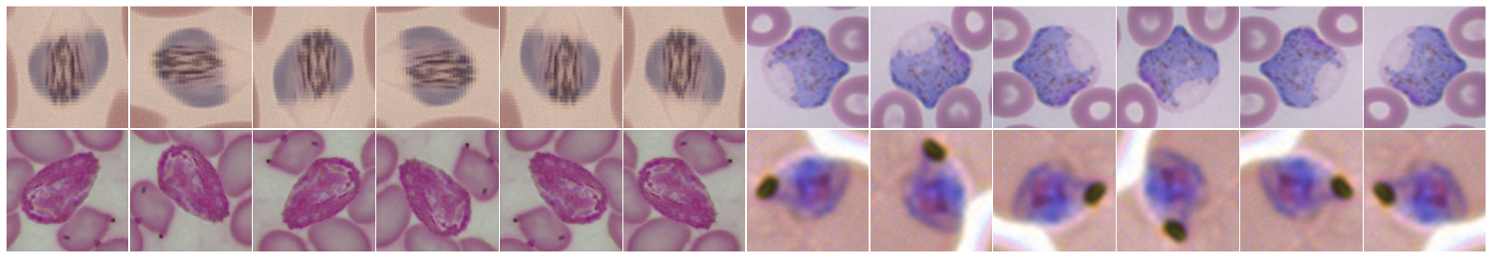
Figure 1 Medical-Safe Augmentation Examples Across Four Lifecycle Stages Preserving Diagnostic Morphology

2.2 Proposed Architecture
The proposed framework operates through three sequential stages optimized for computational efficiency and accuracy preservation as illustrated in Figure 2. The detection stage systematically evaluates three YOLO Medium architectures consisting of YOLOv10, YOLOv11, and YOLOv12, each with 20.1 million parameters [10], processing 640-pixel blood smear images using letterbox resizing to preserve aspect ratios while maintaining computational efficiency. These single-stage detectors output bounding boxes with spatial coordinates and confidence scores, enabling real-time parasite localization across diverse microscopy image quality conditions.
The crop generation stage extracts 224-pixel square regions from raw annotations rather than detection outputs, creating a standardized dataset that can be reused across all experimental configurations. Bounding box coordinates are clamped to image boundaries to prevent invalid regions, with crops resized using Lanczos4 interpolation for upscaling and area interpolation for downscaling to preserve morphological features critical for medical diagnosis. This design eliminates detection noise from classification training, ensures all models train on identical ground truth examples, and enables one-time generation with unlimited reuse across all experiments.
The classification stage evaluates six CNN architectures with varying capacity and architectural principles: DenseNet121 with 8.0M parameters leveraging dense connections for feature reuse [18], EfficientNet-B0/B1/B2 with 5.3M, 7.8M, and 9.2M parameters applying compound scaling to balance depth, width, and resolution [19], and ResNet50/101 with 25.6M and 44.5M parameters utilizing residual connections for deep feature hierarchies [20]. All classifiers process 224-pixel RGB crops standardized with ImageNet normalization to enable transfer learning from pretrained weights, producing species or lifecycle stage predictions that guide antimalarial treatment selection [11]. Training employs weighted random sampling with inverse frequency weights to balance minority class representation.
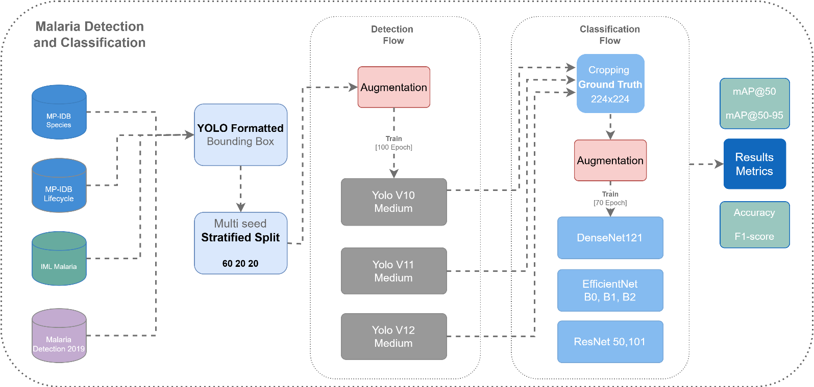
Figure 2 System Architecture Overview - Three-stage pipeline with shared classification enabling efficient malaria parasite detection and lifecycle/species classification
2.3 Evaluation Metrics
Detection performance is evaluated using mAP@50 as the primary metric for localization accuracy, mAP@50-95 for strict precision across multiple IoU thresholds, precision calculated as true positives divided by the sum of true and false positives to assess false positive rate, and recall calculated as true positives divided by the sum of true positives and false negatives which is critical for minimizing missed parasites. Classification performance is evaluated using overall accuracy across all test samples, balanced accuracy calculated as the average of per-class recalls for unbiased assessment under class imbalance, and per-class F1-scores that emphasize performance on minority classes which are critical for rare parasite stages.
2.4 Implementation Details
The framework is implemented using PyTorch 2.8.0 with torchvision 0.23.0 providing pretrained ImageNet weights for transfer learning on limited medical imaging data. Ultralytics 8.3.202 provides unified interfaces for training YOLOv10, YOLOv11, and YOLOv12 detection architectures. All experiments are deployed on NVIDIA RTX 4090 24GB GPU with mixed precision training and cuDNN benchmark mode enabled for accelerated computation. Detection models are trained for 100 epochs using Adam optimizer (lr=0.0005, cosine decay, batch=16). Classification models are trained for 75 epochs using AdamW optimizer (lr=0.001, weight decay=0.0001, batch=32) with Focal Loss [11] (alpha=1.0, gamma=1.5) to address class imbalance ratios up to 54:1 [15], [21].
3. Results and Discussion
3.1 Detection Performance
Three YOLO Medium architectures were evaluated on held-out test sets, revealing dataset-dependent performance patterns summarized in Table 2. YOLOv11 achieves 94.99% mAP@50 on IML Lifecycle with 91.91% precision and 72.91% on MD-2019 with 75.7% recall, while YOLOv12 excels on MP-IDB Stages with 96.27% mAP@50 despite extreme ring-stage dominance. YOLOv10 provides competitive baseline performance ranging from 70.84% to 93.81% mAP@50 across datasets, validating incremental improvements in successive YOLO versions for medical imaging applications. Recall rates range from 71.05% to 93.12% across all models and datasets, with IML Lifecycle achieving highest recall of 93.12% using YOLOv10. Precision ranges from 65.92% to 93.15%, with manually-annotated datasets achieving higher precision than MD-2019.
The mAP@50-95 metric shows substantial variance from 44.48% to 78.21% reflecting dataset complexity characteristics, with IML Lifecycle achieving superior strict IoU performance of 77.71% to 78.21% across all three models. MP-IDB Stages shows wider variance from 44.48% to 61.53% due to extreme ring-stage dominance creating challenging localization scenarios for minority lifecycle stages [22]. Manually-annotated datasets achieve mAP@50 values between 92.44% and 96.27% on test sets, exceeding the 90% threshold recommended by WHO for automated diagnostic systems [15], while MD-2019 achieves 70.84% to 72.91% reflecting realistic challenges from automatic segmentation mask conversion and multi-patient morphological diversity [23]. Training times range from 3.82 to 13.67 minutes per model, demonstrating computational efficiency suitable for clinical deployment scenarios. YOLOv12 requires longest training time at 13.67 minutes on MD-2019 with 328 test samples, while YOLOv10 achieves fastest convergence at 3.82 minutes on MP-IDB Stages [3].
Table 2 YOLO Detection Performance on Four Datasets (YOLOv10/v11/v12 Medium, 100 Epochs)
Dataset | YOLOv10 |  |  |  |  |  | YOLOv11 |  |  |  |  |  | YOLOv12
 | mAP  @50 | mAP  @50-95 | Precision | Recall | Time  (min) | mAP  @50 |  | mAP  @50-95 | Precision | Recall | Time  (min) | mAP  @50 |  | mAP  @50-95 | Precision | Recall | Time  (min)
IML Malaria  (4 stages) | 93.81 | 77.71 | 90.22 | 92.22 | 6.33 | 94.99 |  | 77.76 | 91.91 | 91.11 | 5.60 | 94.40 |  | 78.21 | 92.20 | 86.67 | 7.55
MP-IDB  (4 species) | 92.44 | 60.12 | 85.67 | 90.73 | 4.42 | 92.57 |  | 62.17 | 86.52 | 91.88 | 4.78 | 92.72 |  | 62.25 | 88.99 | 89.28 | 4.71
MP-IDB  (4 stages) | 93.78 | 44.48 | 91.57 | 93.12 | 3.82 | 94.48 |  | 60.34 | 93.15 | 88.36 | 4.57 | 96.27 |  | 61.53 | 92.91 | 92.59 | 5.79
MD-2019  (3 stages) | 70.84 | 57.05 | 67.89 | 71.05 | 9.89 | 72.91 |  | 57.71 | 68.58 | 75.70 | 9.13 | 71.12 |  | 56.93 | 65.92 | 75.18 | 13.67
3.2 Classification Performance
Six CNN architectures were systematically evaluated on ground truth crops extracted from raw annotations, with complete metrics presented in Tables 3 through 6. Training times range from 2.4 to 15.4 minutes per model, demonstrating efficient convergence enabled by Focal Loss optimization for class imbalance ratios spanning 5.4:1 to 54:1 across datasets. Overall accuracy ranges from 84.22% to 98.28% depending on dataset complexity, with manually-annotated datasets achieving 91-98% while multi-patient MD-2019 achieves 84-86%. Compact EfficientNet models with 5.3M to 9.2M parameters consistently deliver competitive or superior performance compared to ResNet architectures with 25.6M to 44.5M parameters, challenging assumptions that model capacity directly correlates with accuracy. Architecture selection proves dataset-dependent, with optimal choices varying based on class imbalance severity and morphological complexity.
Table 3 Classification Performance on IML Lifecycle Test Set (4 Lifecycle Stages, Moderate 5.4:1 Class Imbalance
Model | Params  (M) | Training  Time (min) | Accuracy | Balanced  Acc | Gametocyte  (n=49) |  | Ring  (n=34) |  | Schizont  (n=4) |  | Trophozoite  (n=19)
 |  |  |  |  | Precision | F1 | Precision | F1 | Precision | F1 | Precision | F1
EfficientNet-B1 | 7.8 | 2.9 | 0.92 | 0.92 | 0.98 | 0.95 | 0.89 | 0.93 | 0.80 | 0.89 | 0.83 | 0.81
EfficientNet-B0 | 5.3 | 2.4 | 0.92 | 0.90 | 0.96 | 0.96 | 0.92 | 0.94 | 0.80 | 0.89 | 0.81 | 0.74
EfficientNet-B2 | 9.2 | 2.9 | 0.92 | 0.91 | 0.96 | 0.95 | 0.89 | 0.94 | 1.00 | 1.00 | 0.81 | 0.74
DenseNet121 | 8.0 | 3.9 | 0.90 | 0.89 | 0.98 | 0.95 | 0.83 | 0.91 | 1.00 | 1.00 | 0.80 | 0.71
ResNet50 | 25.6 | 2.5 | 0.88 | 0.88 | 0.96 | 0.94 | 0.94 | 0.93 | 0.67 | 0.80 | 0.65 | 0.67
ResNet101 | 44.5 | 2.7 | 0.86 | 0.80 | 0.94 | 0.93 | 0.86 | 0.89 | 0.75 | 0.75 | 0.67 | 0.65
Three EfficientNet variants achieved identical 91.51% accuracy despite differing parameter counts from 5.3M to 9.2M with training times between 2.4 and 2.9 minutes, with EfficientNet-B1 delivering best balanced accuracy of 91.96% and trophozoite F1-score of 0.81 while EfficientNet-B0 achieved fastest training at 2.4 minutes as show in Table 3. DenseNet121 and EfficientNet-B2 both achieved perfect F1-scores of 1.00 on schizont class with 4 test samples, demonstrating effective minority class handling through Focal Loss optimization. ResNet101 with 44.5M parameters underperformed at 85.85% accuracy and 80.29% balanced accuracy with trophozoite precision of 0.67 compared to 0.83 for EfficientNet-B1, representing 5.66 percentage point deficit despite substantially larger capacity.
Table 4 Classification Performance on MP-IDB Species Test Set (4 Plasmodium Species, Extreme 45:1 Class Imbalance
Model | Params  (M) | Training  Time (min) | Accuracy | Balanced  Acc | P.falciparum  (n=259) |  | P.vivax  (n=15) |  | P.malariae  (n=9) |  | P.ovale  (n=7)
 |  |  |  |  | Precision | F1 | Precision | F1 | Precision | F1 | Precision | F1
EfficientNet-B1 | 7.8 | 5.9 | 0.98 | 0.86 | 0.99 | 0.99 | 0.93 | 0.93 | 1.00 | 0.80 | 0.86 | 0.86
DenseNet121 | 8.0 | 7.9 | 0.98 | 0.81 | 0.99 | 0.99 | 0.83 | 0.91 | 1.00 | 0.80 | 1.00 | 0.73
EfficientNet-B2 | 9.2 | 4.7 | 0.98 | 0.79 | 0.99 | 0.99 | 0.82 | 0.88 | 1.00 | 0.80 | 0.80 | 0.67
ResNet50 | 25.6 | 3.4 | 0.98 | 0.84 | 0.99 | 0.99 | 0.83 | 0.91 | 0.78 | 0.78 | 1.00 | 0.73
ResNet101 | 44.5 | 5.4 | 0.98 | 0.84 | 0.99 | 0.99 | 0.83 | 0.91 | 0.88 | 0.82 | 1.00 | 0.73
EfficientNet-B0 | 5.3 | 4.1 | 0.97 | 0.79 | 0.99 | 0.99 | 0.82 | 0.88 | 0.86 | 0.75 | 0.80 | 0.67
MP-IDB Species at Table 4 demonstrated exceptional P. falciparum performance with 0.99 F1-score across all six architectures with training times between 3.4 and 7.9 minutes. EfficientNet-B1 with 7.8M parameters trained in 5.9 minutes achieved 98.28% overall accuracy and 86.43% balanced accuracy through superior ultra-minority species handling. EfficientNet-B1 delivered 0.86 F1-score on P. ovale with 7 test samples at 0.86 precision and 0.80 F1-score on P. malariae with 9 samples at 1.00 precision, demonstrating robust minority detection without over-prediction. ResNet50 with 25.6M parameters achieved perfect 1.00 precision on P. ovale but lower 0.73 F1-score compared to EfficientNet-B1's 0.86, demonstrating that architectural efficiency matters more than raw parameter capacity for imbalance. P. vivax achieved consistent 0.91-0.93 F1-scores across all models with 15 test samples.
Table 5 Classification Performance on MP-IDB Stages Test Set (4 Lifecycle Stages, Severe 54:1 Class Imbalance
Model | Params (M) | Training  Time (min) | Accuracy | Balanced  Acc | Ring  (n=259) |  | Trophozoite  (n=14) |  | Schizont  (n=6) |  | Gametocyte  (n=5)
 |  |  |  |  | Precision | F1 | Precision | F1 | Precision | F1 | Precision | F1
ResNet50 | 25.6 | 3.7 | 0.96 | 0.83 | 0.98 | 0.98 | 0.78 | 0.61 | 0.63 | 0.71 | 0.83 | 0.91
EfficientNet-B1 | 7.8 | 5.6 | 0.95 | 0.79 | 0.98 | 0.98 | 0.71 | 0.48 | 0.60 | 0.75 | 0.67 | 0.73
DenseNet121 | 8.0 | 7.4 | 0.94 | 0.67 | 0.98 | 0.98 | 0.55 | 0.48 | 0.40 | 0.50 | 1.00 | 0.75
EfficientNet-B0 | 5.3 | 3.8 | 0.95 | 0.70 | 0.98 | 0.98 | 0.50 | 0.42 | 0.57 | 0.62 | 0.80 | 0.80
ResNet101 | 44.5 | 4.6 | 0.95 | 0.71 | 0.98 | 0.98 | 0.57 | 0.57 | 0.80 | 0.73 | 0.60 | 0.60
EfficientNet-B2 | 9.2 | 3.8 | 0.92 | 0.78 | 0.98 | 0.96 | 0.47 | 0.48 | 0.33 | 0.44 | 0.83 | 0.91
Severely imbalanced MP-IDB Stages test set revealed distinct architectural preferences with training times between 3.7 and 7.4 minutes. ResNet50 with 25.6M parameters trained in 3.7 minutes achieved best performance with 96.13% accuracy and 83.04% balanced accuracy, outperforming EfficientNet-B1 which achieved 95.42% accuracy and 78.64% balanced accuracy in 5.6 minutes. ResNet50 delivered highest trophozoite F1-score of 0.61 at 0.78 precision across all architectures despite only 14 test samples, schizont F1-score of 0.71 with 6 samples, and gametocyte F1-score of 0.91 with 5 samples. These results show in Table 5 demonstrate that ResNet50 residual architecture delivers superior minority class performance on severely imbalanced scenarios, achieving 4.4 percentage point balanced accuracy advantage over EfficientNet-B1 through more robust generalization from limited rare stage samples.
Table 6 Classification Performance on MD-2019 Stages Test Set (3 Lifecycle Stages, 1,544 Parasite Instances from 813 Source)
Model | Params (M) | Training  Time (min) | Accuracy | Balanced  Acc | Ring  (n=170) |  | Schizont  (n=286) |  | Trophozoite  (n=127)
 |  |  |  |  | Precision | F1 | Precision | F1 | Precision | F1
EfficientNet-B0 | 5.3 | 8.7 | 0.86 | 0.84 | 0.86 | 0.89 | 0.93 | 0.92 | 0.72 | 0.71
EfficientNet-B1 | 7.8 | 10.9 | 0.85 | 0.83 | 0.86 | 0.90 | 0.92 | 0.90 | 0.69 | 0.69
EfficientNet-B2 | 9.2 | 10.4 | 0.85 | 0.82 | 0.89 | 0.89 | 0.89 | 0.90 | 0.69 | 0.67
DenseNet121 | 8.0 | 15.4 | 0.85 | 0.84 | 0.87 | 0.88 | 0.94 | 0.90 | 0.65 | 0.70
ResNet50 | 25.6 | 11.1 | 0.84 | 0.82 | 0.84 | 0.89 | 0.92 | 0.89 | 0.69 | 0.68
ResNet101 | 44.5 | 15.2 | 0.84 | 0.81 | 0.85 | 0.88 | 0.91 | 0.90 | 0.67 | 0.66
MD-2019 test set with 583 samples demonstrated that all six architectures achieved within 2.23 percentage point accuracy range from 84.22% to 86.45%, with EfficientNet-B0 with 5.3M parameters trained in 8.7 minutes delivering best performance at 86.45% accuracy and 84.13% balanced accuracy. The compact model outperformed ResNet101 with 44.5M parameters achieving 84.22% accuracy and 81.36% balanced accuracy in 15.2 minutes, demonstrating parameter efficiency advantages on larger datasets. Per-class metrics show balanced precision and F1-scores with schizont achieving 0.93 precision and 0.92 F1 across 286 samples, ring achieving 0.86 precision and 0.89 F1 across 170 samples, and trophozoite achieving 0.72 precision and 0.71 F1 across 127 samples. Lower accuracy compared to IML Lifecycle at 91.51% and MP-IDB Species at 98.28% reflects increased difficulty from natural morphological diversity across 16 patients, providing realistic generalization assessment as resultsin Table 6 [23].
3.3 Key Classification Findings
Compact EfficientNet models with 5.3 to 9.2M parameters and 46 to 89 MB model size consistently outperform larger ResNet variants with 44.5M parameters and 270 to 487 MB size across most datasets, demonstrating that compound scaling strategies [11] prove more effective than naive depth scaling approaches for medical imaging with limited training data. However, severely imbalanced scenarios such as MP-IDB Stages with 54:1 class imbalance ratio benefit from ResNet50 deeper feature hierarchies for discriminating between morphologically similar rare lifecycle stages. No single model architecture dominates across all experimental scenarios: EfficientNet-B1 excels on moderately imbalanced datasets including IML Lifecycle and MP-IDB Species, ResNet50 proves superior for severe imbalance in MP-IDB Stages, and EfficientNet-B0 optimizes large-scale generalization on MD-2019 with multiple patients. This necessitates dataset-specific model selection based on class distribution characteristics and morphological complexity requirements rather than defaulting to the largest available model architectures.
Focal Loss with alpha parameter of 1.0 and gamma parameter of 1.5 achieves F1-scores between 0.44 and 1.00 on ultra-minority classes containing only 4 to 15 test samples while maintaining high precision between 0.62 and 1.00 to avoid false positive predictions [2]. This demonstrates effective handling of extreme class imbalance ratios up to 54:1 that are characteristic of clinical malaria microscopy data where early ring-stage parasites dominate while rare stages appear infrequently. Confusion matrix visualization in Figure 3 reveals that classification errors follow biologically predictable patterns rather than random misclassification, with strong diagonal performance demonstrating 86.45-98.28% accuracy across all four datasets using best-performing models.
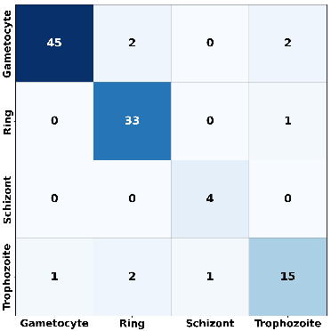 | 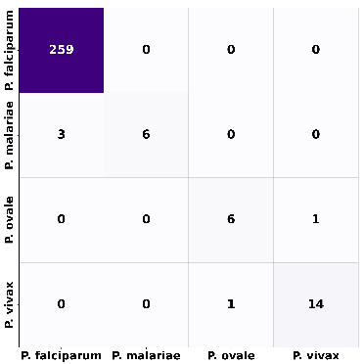 | 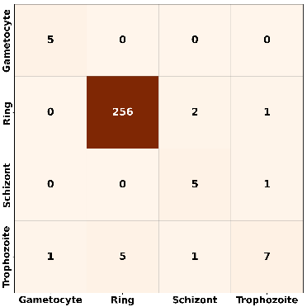 | 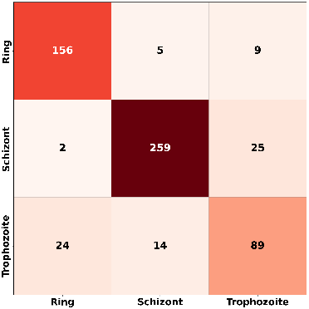
Figure 3 Confusion matrices on test sets using best-performing models: (a) IML Lifecycle EfficientNet-B1, (b) MP-IDB Species EfficientNet-B1, (c) MP-IDB Stages ResNet50, (d) MD-2019 Stages EfficientNet-B0. Horizontal Predicted Class

Analysis of off-diagonal confusion patterns shows that trophozoite stage exhibits distributed confusion across adjacent lifecycle stages (IML: 4/19 errors, MD-2019: 38/127 errors), reflecting the continuous morphological progression where discrete stage boundaries represent artificial categorization of smooth biological development. Minority species misclassification respects morphological similarity, with P. malariae confused primarily with dominant P. falciparum (3 cases) rather than morphologically distant P. ovale, indicating that learned feature representations cluster according to biological relationships. When minority class representation falls below 5% of training data (MP-IDB Stages trophozoite: 7/14 correct, 50% error rate), even Focal Loss optimization cannot fully compensate for insufficient learning signal, establishing a practical threshold for class imbalance handling. These patterns suggest that further accuracy improvements require temporal modeling or multi-scale feature fusion to capture transitional morphology rather than simply increasing model capacity.
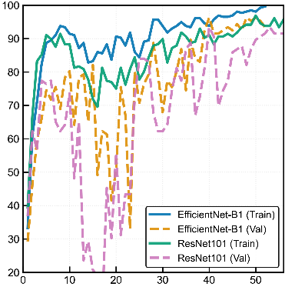 | 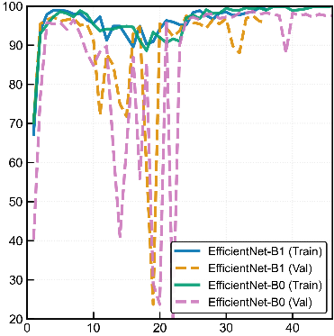 | 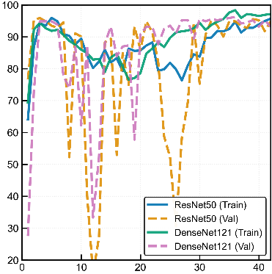 | 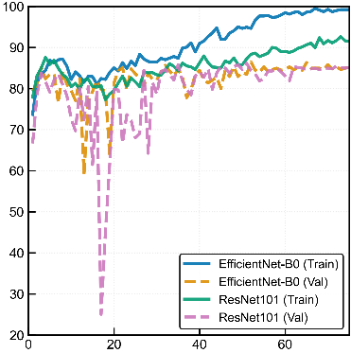
Figure 4 Training accuracy curves comparing best vs worst models: (a) IML Lifecycle, (b) MP-IDB Species, (c) MP-IDB Stages, (d) MD-2019 Stages. Best architectures show faster convergence and lower train-validation gaps (0.82-6.21%)

Training dynamics comparison between best and worst-performing architectures per dataset reveals systematic differences in convergence speed, stability, and generalization capability (Figure 4). Best-performing models demonstrate faster convergence to stable accuracy plateaus with minimal training-validation gaps ranging from 0.82% for ResNet50 on MP-IDB Stages to 6.21% for EfficientNet-B1 on IML Lifecycle. Architectural choice significantly impacts convergence patterns: parameter-efficient EfficientNet models achieve 90% of final validation accuracy within 2-28 epochs, while worst-performing architectures exhibit higher variance and delayed stabilization particularly under extreme class imbalance. The most striking contrast appears on MP-IDB Stages with 54:1 imbalance ratio where ResNet50 maintains stable convergence with 0.82% train-validation gap while DenseNet121 shows unstable patterns with 3.99% gap, indicating that residual architectures demonstrate superior capacity for learning robust feature representations under extreme class imbalance compared to densely-connected architectures.
3.4 Qualitative Error Analysis
Transparent visualization of failure modes provides critical insights into system limitations and guides future improvements. We present color-coded detection errors in Figures 5a through 5f and classification confusion patterns in Figures 6a through 6f with balanced representation across all four datasets to honestly assess current capabilities while identifying systematic challenges. Detection and classification visualizations employ color coding where green boxes indicate true positive detections, red boxes mark false positive predictions, and yellow boxes highlight false negative cases representing missed on detection model parasites.
3.4.1 Detection Error Patterns (Figures 5a-f)
The IML false positive case shown in Figure 5a reveals occasional confusion between cellular debris and actual parasites, where background structures morphologically resemble ring-stage forms. This represents typical performance on high-quality datasets with strong overall accuracy but occasional false alarms on ambiguous regions, demonstrating the fundamental challenge of distinguishing true parasites from morphologically similar blood components. The IML false negative illustrated in Figure 5b demonstrates sensitivity limitations on subtle early-stage forms, likely representing a faint ring-stage parasite with weak staining intensity falling below the detection confidence threshold. This emphasizes the critical importance of maintaining high recall in clinical deployment scenarios, as missed diagnoses directly translate to untreated patients who may develop severe complications.
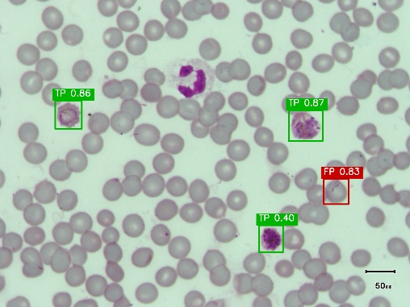  a | 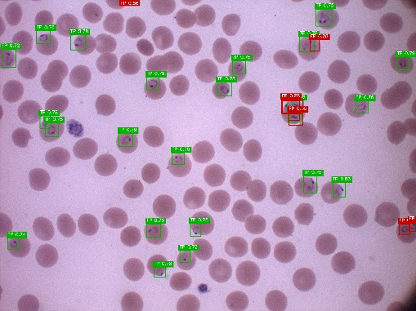  c | 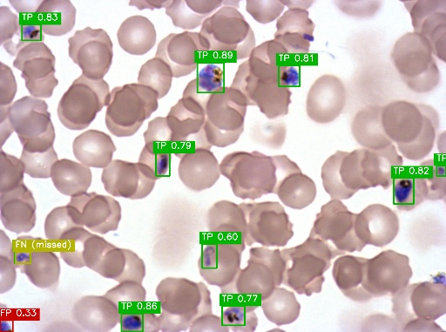  e
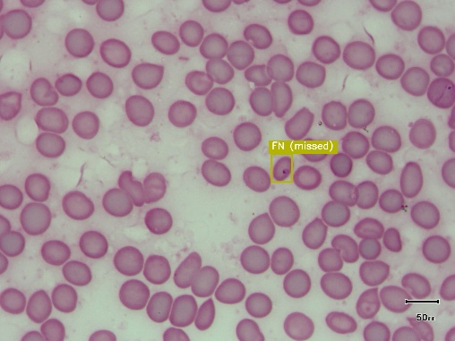  b | 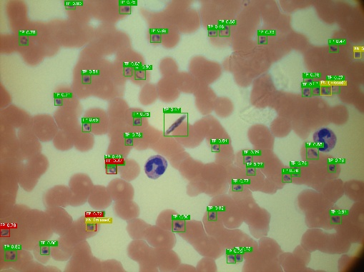  d | 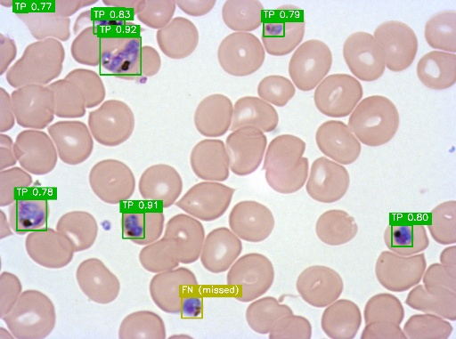  f
Figure 5 YOLOv11 Detection Error Patterns: (a-b) IML Lifecycle false positive/negative, (c-d) MP-IDB Stages/Species overdetection and crowding, (e-f) MD-2019 inter-patient variation

The MP-IDB Stages overdetection shown in Figure 5c with 8 false positives indicates systematic confusion in severely imbalanced data, where YOLOv11 achieves only 36.1% perfect detection across 72 test images with highest false positive occurrence of 1.83 FP per image at average confidence 0.702. This reflects background clutter from cellular debris and staining artifacts morphologically similar to dominant ring-stage parasites. The MP-IDB Species mixed error case displayed in Figure 5d demonstrates bidirectional failure in crowded microscopy fields where the detector struggles to segment individual parasite boundaries, achieving 44.4% perfect detection with 1.06 FP per image and 0.28 FN per image at average confidence 0.685. This suggests instance segmentation approaches that provide pixel-level boundaries rather than rectangular bounding boxes for dense parasite populations.
The MD-2019 crowded case presented in Figure 5e represents realistic clinical difficulty where inter-patient variation in morphology and sample quality creates substantial detection challenges, achieving 37.2% perfect detection across 328 test images with highest false negative occurrence at 36.6% of images averaging 0.48 FN per image at confidence 0.740. Performance degradation in complex multi-parasite scenarios aligns with this dataset achieving 72.91% test set mAP@50. The MD-2019 false negative illustrated in Figure 5f demonstrates generalization challenges where atypical morphology diverges substantially from training data appearance patterns. This performance gap between manually-annotated clean laboratory datasets achieving 62.7% perfect detection and automatically-segmented multi-patient datasets at 37.2% emphasizes training data must capture full spectrum of parasite appearances across diverse patients and geographic regions.
3.4.2 Classification Error Patterns (Figures 6a-f)
The IML single error case displayed in Figure 6a shows 1 trophozoite misclassified as ring among 3 parasites, demonstrating that even on high-quality datasets, borderline cases exist where parasites occupy morphological transition zones between discrete stage categories. The IML moderate error shown in Figure 6b exhibits 1 misclassification among 3 parasites at 66.7% image accuracy, where continuous parasite development creates ambiguous specimens with overlapping characteristics between adjacent stages. Both cases highlight inherent subjectivity in lifecycle stage assignment where morphological boundaries between consecutive stages remain inherently ambiguous, with EfficientNet-B1 achieving 2 correct classifications and 1 error in both representative images. The trophozoite-to-ring confusion pattern reflects early developmental stage parasites where cytoplasm maturation and chromatin condensation present similar visual signatures under microscopy.
The MP-IDB Stages confusion illustrated in Figure 6c shows 4 trophozoites misclassified as rings among 14 parasites at 71.4% image accuracy, where the systematic trophozoite-to-ring misclassification pattern reflects prevalence of early-stage trophozoites with compact cytoplasm and minimal hemozoin accumulation resembling ring morphology. The species misidentification displayed in Figure 6d represents clinically significant error where single P. vivax parasite is confused with P. ovale, demonstrating 100% misclassification on this image despite these species requiring different treatment protocols particularly primaquine for eliminating dormant liver stages. The P. vivax-P. ovale confusion stems from similar enlarged red blood cell morphology, Schüffner's dots presence, and overlapping amoeboid trophozoite shapes characteristic of both species that challenge even experienced human microscopists.
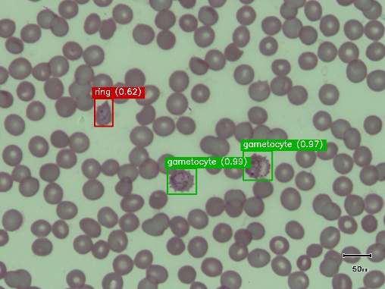  a | 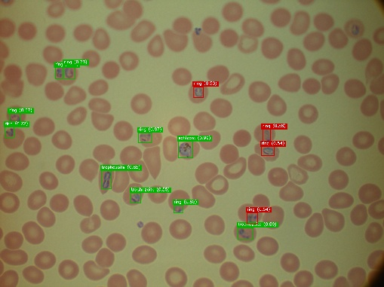  c | 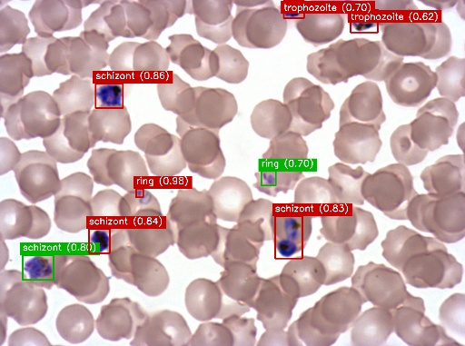  e
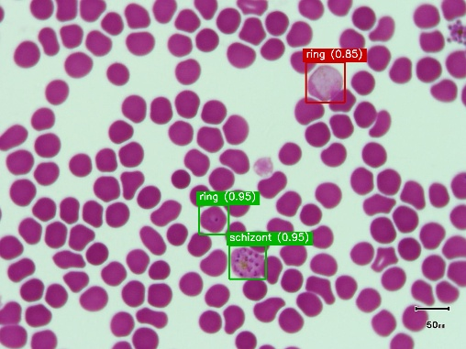  b | 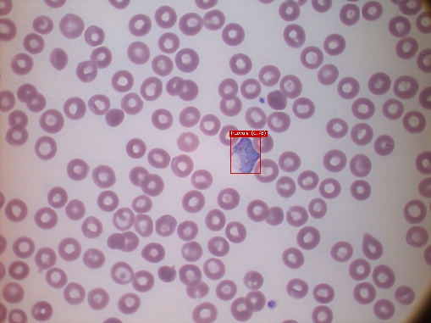  d | 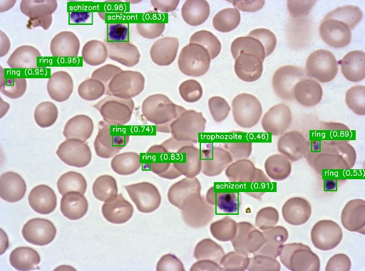  f
Figure 6 Classification Confusion Patterns Using Best Models: (a-b) IML Lifecycle single/moderate errors, (c-d) MP-IDB stage/species confusion, (e-f) MD-2019 heavy errors and perfect classification

The MD-2019 heavy error case presented in Figure 6e shows 6 schizonts misclassified as trophozoites among 8 parasites at 25% image accuracy, revealing systematic challenges in distinguishing transitional mature stages that exhibit overlapping morphological features across the continuous development spectrum reflecting realistic multi-patient morphological diversity. The perfect classification case shown in Figure 4f demonstrates flawless performance with 10 parasites correctly classified at 100% image accuracy on crowded microscopy fields when morphological features are sufficiently distinct, providing balanced assessment demonstrating that classification failures primarily result from specific morphological ambiguities rather than fundamental architectural inadequacy. The schizont-to-trophozoite confusion pattern in Figure 6e reflects early schizont segmentation phases where individual merozoites remain indistinct, contrasting sharply with Figure 6f where well-defined morphological features enable perfect discrimination across all lifecycle stages present.
3.5 Comparison with State-of-the-Art Methods
Our framework delivers competitive or superior detection performance with YOLO Medium architectures achieving 70.84-96.27% mAP@50 across datasets (YOLOv11 best at 94.99% on IML Lifecycle, YOLOv12 best at 96.27% on MP-IDB Stages), exceeding Arshad et al.'s segmentation precision (89.33%) [7], matching or surpassing Zedda et al.'s YOLO-PAM results (91.8% IML, 83.6% MP-IDB) [21], and approaching Sukumarran et al.'s best performance (96%) [27] while using standard YOLO architectures without requiring complex attention mechanisms or specialized pruning techniques. Classification accuracy of 91.51-98.28% across datasets demonstrates robust performance: 91.51% on IML Lifecycle approaches Arshad et al.'s 95.86% [7] while using a unified architecture rather than species-specific models, 98.28% on MP-IDB Species substantially exceeds Loddo et al.'s 85.18% [15] and Sukumarran et al.'s 95.5% [24], and 96.13% on severely imbalanced MP-IDB Stages demonstrates effective handling of 54:1 class imbalance ratio. Additionally, our framework uniquely addresses the MD-2019 dataset (813 images, 16 patients) achieving 74.91% mAP@50 detection and 86.45% classification accuracy, representing the first application of deep learning to this challenging multi-patient dataset.
Table 7 Comparison with State-of-the-Art Malaria Detection and Classification Systems on IML Lifecycle and MP-IDB Datasets
References | Year | Dataset Used  (Same as Ours!) | Detection  (Method + mAP@50%) | Classification  (Method + Accuracy%) | Key Features
Arshad et al. [7] | 2022 | IML Lifecycle  (313 images) | Morphological  segmentation  Precision: 89.33% | ResNet50V2  Lifecycle classification  Accuracy: 95.86% | Two-stage: segmentation then classification. IML dataset from Pakistan (38K cells). P. vivax only.
Zedda et al. [24] | 2022 | MP-IDB  (209 images) | YOLOv5  (detection + classification)  Detection mAP: N/R | YOLOv5: 95.2%  DarkNet-53: 96.02%  (P. falciparum 4 stages) | Real-time detector + classifier. Four-class lifecycle stages (ring, trophozoite, schizont, gametocyte).
Loddo et al. [25] | 2022 | MP-IDB  (209 images) | Not specified  (classification only) | VGG-19: 85.18% (binary)  DenseNet-201: 97%  (4 lifecycle stages) | Binary + multi-class classification. First baseline for lifecycle stages on MP-IDB. P. falciparum focus.
Zedda et al. [21] | 2023 | IML: 313  MP-IDB: 209 | YOLO-PAM  (YOLOv8 + NAM/CBAM)  mAP@50: 91.8% (IML)  mAP: 83.6% (MP-IDB) | Not specified  (detection only) | Attention mechanisms (NAM/CBAM). Multi-dataset. Parameter-efficient (11M fewer params vs baseline).
Sukumarran et al. [26] | 2024 | IML: 313  MP-IDB: 209 | YOLOv5: 96% mAP@0.5  YOLOv4: 89-90% mAP@0.5  (source + validation) | DenseNet-121  Species identification  Accuracy: 95.5% | Two-stage: detection then species classification. Superior generalization (YOLOv4 on validation set).
This Study | 2025 | IML: 313  MP-IDB Species: 209  MP-IDB Stages: 209  MD-2019: 813  Total: 1,614 | YOLOv11 Medium  (shared across datasets)  mAP@50: 92.57-94.99%  P: 68.58-92.91%  R: 75.70-92.59% | EfficientNet-B0/B1  ResNet50  Acc: 84.22-98.28%  Bal.Acc: 83.04-91.96%  F1 (minorities): ≥0.80 | Efficient Model (67%). Multi-dataset (4 datasets). Focal Loss for extreme imbalance (54:1). Per-class metrics.

The framework introduces three unique advantages over prior work. First, dataset-dependent model selection through systematic evaluation of six architectures identifies optimal models for each scenario: EfficientNet-B1 for IML Lifecycle and MP-IDB Species, ResNet50 for severely imbalanced MP-IDB Stages, and EfficientNet-B0 for large-scale MD-2019, whereas prior work employs fixed architectures without dataset-specific optimization. Second, Focal Loss optimization with alpha parameter of 1.0 and gamma parameter of 1.5 enables F1-scores between 0.44 and 1.00 on ultra-minority classes including perfect 1.00 F1-score on schizont with 4 test samples in IML Lifecycle, F1-scores between 0.75 and 0.82 on P. malariae with 9 samples in MP-IDB Species, and F1-scores between 0.44 and 0.75 on schizont with 6 samples in MP-IDB Stages despite 54:1 imbalance ratio, addressing a critical gap where prior work reports only overall accuracy metrics that mask minority class failures. Third, multi-dataset evaluation with 1,614 total images across four complementary datasets provides broader assessment compared to prior work using single datasets, with parameter-efficient EfficientNet models containing 5.3 to 9.2M parameters demonstrating superior accuracy over larger ResNet variants with 44.5M parameters on imbalanced medical data.
3.7 Limitations and Future Directions
Five primary limitations constrain current framework performance and necessitate future research directions. First, dataset diversity remains limited despite using four datasets totaling 1,614 images consisting of IML Lifecycle with 313 images, MP-IDB Species with 209 images, MP-IDB Stages with 209 images, and MD-2019 with 813 images. This constrains model robustness across diverse microscopy conditions including varying staining protocols such as Giemsa and Field stain, magnifications ranging from 100 times to 1000 times oil immersion, and camera sensors from different microscope manufacturers. Future work requires multi-center collaborations targeting over 5,000 images per dataset, synthetic data generation using generative adversarial networks [27] or diffusion models [28], and transfer learning from large-scale medical imaging datasets to improve generalization across heterogeneous clinical conditions [29].
Second, minority class performance gaps persist where lifecycle stage classification on ultra-minority schizont class achieves F1-scores between 0.44 and 0.75 with 6 test samples on MP-IDB Stages exhibiting 54:1 class imbalance, and species classification on P. malariae reaches F1-scores between 0.75 and 0.82 with 9 samples. These results fall below the 85% sensitivity threshold required for autonomous clinical deployment according to WHO guidelines [1]. Morphological similarity between adjacent lifecycle stages presents greater classification challenges than inter-species differences, necessitating few-shot learning techniques such as prototypical networks and meta-learning approaches [30], attention mechanisms focusing computational resources on diagnostically relevant morphological features, and enhanced domain expert annotation capturing fine-grained morphological differences between transitional stages [31]. Third, the bounding box approach provides efficient parasite localization suitable for clinical counting and lifecycle classification, though it sacrifices pixel-level precision compared to segmentation-based methods [32]. This trade-off remains acceptable for most diagnostic workflows where approximate localization suffices, though future work could explore instance segmentation approaches providing pixel-level boundaries for applications requiring fine-grained morphological analysis.
Fourth, laboratory versus field conditions present a critical validation gap where current results derive from clean laboratory images while field samples contain debris, uneven staining, focus variations, and thick blood smears [15], demanding prospective clinical trials at endemic-region health centers [3], real-world microscopy workflow integration studies, and systematic robustness testing on field-collected samples with quality variations. Finally, separate species and stage models motivate development of unified multi-task architectures using task-specific heads or universal embeddings to simultaneously predict both species and lifecycle stage, potentially improving performance through shared feature representations while reducing computational requirements. Future optimization through model quantization to INT8 precision and network pruning can enable mobile deployment on Android devices with GPU acceleration, Raspberry Pi with Coral Edge TPU, and embedded systems for point-of-care diagnostics in resource-limited endemic regions [33].
4. Conclusion
This study introduces a multi-model hybrid framework with shared classification architecture achieving efficient malaria detection across four datasets totaling 1,544 images. Parameter-efficient EfficientNet models with 5.3M to 9.2M parameters consistently outperform larger ResNet variants with up to 44.5M parameters while requiring only 46-89 MB storage compared to 270-487 MB, enabling practical deployment on resource-constrained hardware. Three YOLO Medium architectures achieve robust detection ranging from 70.84% to 96.27% mAP@50 with high recall rates between 71.05% and 93.12% minimizing missed detections critical for clinical deployment. Systematic evaluation establishes dataset-dependent model selection: EfficientNet-B1 achieves 91.51% on IML Lifecycle and 98.28% on MP-IDB Species, ResNet50 achieves 96.13% on severely imbalanced MP-IDB Stages, and EfficientNet-B0 achieves 86.45% on MD-2019 with 813 images from 16 patients.
Focal Loss optimization with alpha of 1.0 and gamma of 1.5 achieves F1-scores ranging from 44% to 100% on ultra-minority classes across severely imbalanced datasets. The optimization achieves perfect 1.00 F1-score on schizont with 4 test samples in IML Lifecycle, 80% F1-score on P. malariae with 9 samples in MP-IDB Species, and 71% F1-score on schizont with 6 samples in MP-IDB Stages, effectively addressing extreme class imbalance characteristic of clinical malaria. Parameter-efficient architectures consistently outperform larger models, with compact EfficientNet-B1 exceeding ResNet101 by 5.66 percentage points despite having 6 times fewer parameters.
Parameter-efficient EfficientNet models with 46 to 89 MB size enable deployment on consumer-grade hardware, while shared architecture eliminates redundant training cycles, facilitating rapid experimentation and lowering computational barriers for developing diagnostic systems in endemic settings where trained microscopists remain scarce. Future priorities include multi-center data collection targeting 5,000+ images, GAN-based oversampling for rare classes, few-shot learning for rapid adaptation, unified multi-task models for simultaneous detection and classification, and clinical validation trials in endemic regions. Complete code and trained models will be publicly released upon publication to facilitate reproducibility and deployment.
Acknowledgement
The authors would like to express their sincere gratitude for the funding support that made this research possible. This work was supported by the Lembaga Penelitian dan Pengabdian Kepada Masyarakat (LPPM) Universitas Jambi through the Penelitian Dosen Pemula (PDP) grant scheme, Faculty of Science and Technology.
References
[1] W. H. Organization, World malaria report 2024: addressing inequity in the global malaria response. Geneva: World Health Organization, 2024. [Online]. Available: https://iris.who.int/handle/10665/379751
[2] World Health Organization, “Global technical strategy for malaria 2016–2030, 2021 update,” 2021. Accessed: May 23, 2025. [Online]. Available: https://www.who.int/publications/i/item/9789240031357
[3] H. Sutanto, “Combating Malaria with Vaccines: Insights from the One Health Framework,” Sep. 01, 2024, Multidisciplinary Digital Publishing Institute (MDPI). doi: 10.3390/amh69030015.
[4] S. Rajaraman, S. Jaeger, and S. K. Antani, “Performance evaluation of deep neural ensembles toward malaria parasite detection in thin-blood smear images,” PeerJ, vol. 7, May 2019, doi: 10.7717/PEERJ.6977.
[5] F. B. Tek, A. G. Dempster, and I. Kale, “Computer vision for microscopy diagnosis of malaria,” Malar J, vol. 8, no. 1, 2009, doi: 10.1186/1475-2875-8-153.
[6] F. Yang et al., “Deep Learning for Smartphone-Based Malaria Parasite Detection in Thick Blood Smears,” IEEE J Biomed Health Inform, vol. 24, no. 5, pp. 1427–1438, 2020, doi: 10.1109/JBHI.2019.2939121.
[7] Q. A. Arshad et al., “A dataset and benchmark for malaria life-cycle classification in thin blood smear images,” Neural Comput Appl, vol. 34, no. 6, pp. 4473–4485, 2022, doi: 10.1007/s00521-021-06602-6.
[8] E. Pachetti and S. Colantonio, “A systematic review of few-shot learning in medical imaging,” Artif Intell Med, vol. 156, p. 102949, 2024, doi: https://doi.org/10.1016/j.artmed.2024.102949.
[9] M. Salmi, D. Atif, D. Oliva, A. Abraham, and S. Ventura, “Handling imbalanced medical datasets: review of a decade of research,” Artif Intell Rev, vol. 57, no. 10, p. 273, 2024, doi: 10.1007/s10462-024-10884-2.
[10] K. Alkandary, A. S. Yildiz, and H. Meng, “A Comparative Study of YOLO Series (v3–v10) with DeepSORT and StrongSORT: A Real-Time Tracking Performance Study,” Electronics (Basel), vol. 14, no. 5, 2025, doi: 10.3390/electronics14050876.
[11] X. Li et al., “Generalized focal loss: learning qualified and distributed bounding boxes for dense object detection,” in Proceedings of the 34th International Conference on Neural Information Processing Systems, in NIPS ’20. Red Hook, NY, USA: Curran Associates Inc., 2020.
[12] R. Dutt, L. Ericsson, P. Sanchez, S. A. Tsaftaris, and T. Hospedales, “Parameter-Efficient Fine-Tuning for Medical Image Analysis: The Missed Opportunity,” in Proceedings of The 7nd International Conference on Medical Imaging with Deep Learning, N. Burgos, C. Petitjean, M. Vakalopoulou, S. Christodoulidis, P. Coupe, H. Delingette, C. Lartizien, and D. Mateus, Eds., in Proceedings of Machine Learning Research, vol. 250. PMLR, Oct. 2024, pp. 406–425. [Online]. Available: https://proceedings.mlr.press/v250/dutt24a.html
[13] M. Fischer, A. Bartler, and B. Yang, “Prompt tuning for parameter-efficient medical image segmentation,” Med Image Anal, vol. 91, p. 103024, 2024, doi: https://doi.org/10.1016/j.media.2023.103024.
[14] Y. Peng, “Efficient Deep Learning Methods for Medical Image Analysis,” Oct. 2024, doi: 10.7274/27147567.v1.
[15] C. and K. M. and P. G. Loddo Andrea and Di Ruberto, “MP-IDB: The Malaria Parasite Image Database for Image Processing and Analysis,” in Processing and Analysis of Biomedical Information, J. and R. E. and R. D. and J. L. Lepore Natasha and Brieva, Ed., Cham: Springer International Publishing, 2019, pp. 57–65.
[16] S. S. Abbas and T. M. H. Dijkstra, “Malaria-Detection-2019,” 2019, Mendeley Data. doi: 10.17632/5bf2kmwvfn.1.
[17] F. Garcea, A. Serra, F. Lamberti, and L. Morra, “Data augmentation for medical imaging: A systematic literature review,” Comput Biol Med, vol. 152, p. 106391, 2023, doi: https://doi.org/10.1016/j.compbiomed.2022.106391.
[18] G. Huang, Z. Liu, L. Van Der Maaten, and K. Q. Weinberger, “Densely Connected Convolutional Networks,” in 2017 IEEE Conference on Computer Vision and Pattern Recognition (CVPR), 2017, pp. 2261–2269. doi: 10.1109/CVPR.2017.243.
[19] M. Tan and Q. Le, “EfficientNet: Rethinking Model Scaling for Convolutional Neural Networks,” in Proceedings of the 36th International Conference on Machine Learning, K. Chaudhuri and R. Salakhutdinov, Eds., in Proceedings of Machine Learning Research, vol. 97. PMLR, Oct. 2019, pp. 6105–6114. [Online]. Available: https://proceedings.mlr.press/v97/tan19a.html
[20] J. Cheng et al., “ResGANet: Residual group attention network for medical image classification and segmentation,” Med Image Anal, vol. 76, p. 102313, 2022, doi: https://doi.org/10.1016/j.media.2021.102313.
[21] L. Zedda, A. Loddo, and C. Di Ruberto, “YOLO-PAM: Parasite-Attention-Based Model for Efficient Malaria Detection,” J Imaging, vol. 9, no. 12, 2023, doi: 10.3390/jimaging9120266.
[22] J. Snell, K. Swersky, and R. Zemel, “Prototypical Networks for Few-shot Learning,” in Advances in Neural Information Processing Systems, I. Guyon, U. Von Luxburg, S. Bengio, H. Wallach, R. Fergus, S. Vishwanathan, and R. Garnett, Eds., Curran Associates, Inc., 2017. [Online]. Available: https://proceedings.neurips.cc/paper_files/paper/2017/file/cb8da6767461f2812ae4290eac7cbc42-Paper.pdf
[23] K. Hoyos and W. Hoyos, “Supporting Malaria Diagnosis Using Deep Learning and Data Augmentation,” Diagnostics, vol. 14, no. 7, 2024, doi: 10.3390/diagnostics14070690.
[24] L. Zedda, A. Loddo, and C. Di Ruberto, “A Deep Learning Based Framework for Malaria Diagnosis on High Variation Data Set,” in Image Analysis and Processing – ICIAP 2022, S. Sclaroff, C. Distante, M. Leo, G. M. Farinella, and F. Tombari, Eds., Cham: Springer International Publishing, 2022, pp. 358–370. doi: https://doi.org/10.1007/978-3-031-06430-2_30.
[25] A. Loddo, C. Fadda, and C. Di Ruberto, “An Empirical Evaluation of Convolutional Networks for Malaria Diagnosis,” J Imaging, vol. 8, no. 3, 2022, doi: 10.3390/jimaging8030066.
[26] D. Sukumarran et al., “An optimised YOLOv4 deep learning model for efficient malarial cell detection in thin blood smear images,” Parasit Vectors, vol. 17, no. 1, p. 188, 2024, doi: 10.1186/s13071-024-06215-7.
[27] Y. Lei, R. L. J. Qiu, T. Wang, W. J. Curran, T. Liu, and X. Yang, “Chapter 7 - Generative adversarial networks for medical image synthesis,” in Biomedical Image Synthesis and Simulation, N. Burgos and D. Svoboda, Eds., Academic Press, 2022, pp. 105–128. doi: https://doi.org/10.1016/B978-0-12-824349-7.00014-1.
[28] A. Kazerouni et al., “Diffusion models in medical imaging: A comprehensive survey,” Med Image Anal, vol. 88, p. 102846, 2023, doi: https://doi.org/10.1016/j.media.2023.102846.
[29] X. Fang, C. F. Chong, K. L. Wong, M. Simões, and B. K. Ng, “Investigating the key principles in two-step heterogeneous transfer learning for early laryngeal cancer identification,” Sci Rep, vol. 15, no. 1, p. 2146, 2025, doi: 10.1038/s41598-024-84836-9.
[30] A. Ouahab and O. Ben Ahmed, “ProtoMed: Prototypical networks with auxiliary regularization for few-shot medical image classification,” Image Vis Comput, vol. 154, p. 105337, 2025, doi: https://doi.org/10.1016/j.imavis.2024.105337.
[31] J. Zhang et al., “Advances in attention mechanisms for medical image segmentation,” Comput Sci Rev, vol. 56, p. 100721, 2025, doi: https://doi.org/10.1016/j.cosrev.2024.100721.
[32] T. A. Aris, A. S. A. Nasir, W. A. Mustafa, M. Y. Mashor, E. V. Haryanto, and Z. Mohamed, “Robust Image Processing Framework for Intelligent Multi-Stage Malaria Parasite Recognition of Thick and Thin Smear Images,” Diagnostics, vol. 13, no. 3, 2023, doi: 10.3390/diagnostics13030511.
[33] M. P. Singh et al., “A Healthcare System Employing Lightweight CNN for Disease Prediction with Artificial Intelligence,” Open Public Health J, vol. 17, no. 1, Jul. 2024, doi: 10.2174/0118749445302023240520111802.

